**Name : Aditi Nikam Roll No : 323045**

**GR No : 21910513 Class : TY Comp C2**

**WEEK 2**

**Code 1:**

import pandas as pd

import os

df = pd.read_csv('emot.csv')

df_st = pd.DataFrame()

file = open("alp.txt","r")

file.seek(0)

emot_val = df['Mnemonic'].tolist()

first_str = ''

symbols = []

lc_val = []

size = []

lc = 0

for i in file:

    data = i.strip()

*str* = data.split(" ")

    # print(str)

    first_str = str[0]

    x = data.find('DC')

    res = ''.join(filter(*lambda* *i*: i.isdigit(), data))

    if str[0] == 'START':

        lc = *int*(str[1])-1

        # print(lc)

    if first_str not in emot_val:

        symbols.append(first_str)

        lc_val.append(lc)

        size.append(1)

    if x!=-1:

        # print(res)

        lc=lc+*int*(res)

    else:

        lc = lc + 1

st_values = pd.Series(symbols)

lc_values = pd.Series(lc_val)

sizes = pd.Series(size)

df_st.insert(*loc*=0, *column*='Symbol', *value* = st_values)

df_st.insert(*loc*=1, *column*='Size', *value* = sizes)

df_st.insert(*loc*=2, *column* = 'LC', *value* = lc_values)

df_st.to_csv('ST.csv')

print(df_st)

**emot.csv:**

Mnemonic,Class,Opcode

STOP ,1,0

ADD,1,1

SUB,1,2

MULT,1,3

MOVER,1,4

MOVEM,1,5

COMP,1,6

BC,1,7

DIV,1,8

READ,1,9

PRINT,1,10

START,3,1

END,3,2

ORIGIN,3,3

EQU,3,4

LTORG,3,5

DS,2,1

DC,2,2

AREG,4,1

BREG,4,2

CREG,4,3

EQ,5,1

LT,5,2

GT,5,3

NE,5,4

LE,5,5

GT,5,6

ANY,5,7

**alp.txt:**

START 100

MOVER AREG,X

L1 ADD BREG,ONE

COMP BREG,TEN

BC EQ,LAST

ADD AREG,ONE

BC ANY,L1

LAST STOP

X DC '5'

ONE DC '1'

TEN DC '10'

END

**Output 1:**

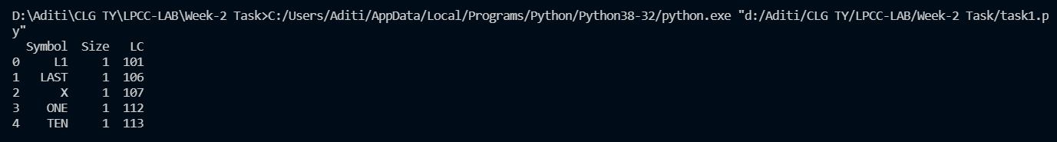

**ST.csv:**

,Symbol,Size,LC

0,L1,1,101

1,LAST,1,106

2,X,1,107

3,ONE,1,112

4,TEN,1,113

**Code 2:**

import pandas as pd

df = pd.DataFrame()

file = open("p5.txt","r")

file.seek(0)

literals = []

lc_val = []

lc = 0

for i in file:

    data = i.strip()

*str* = data.split(" ",1)

    x = data.find('=')

    if str[0] == 'START':

        lc = *int*(str[1])-1

        # print(lc)

    else:

        lc = lc + 1

    if x != -1:

        res = ''.join(filter(*lambda* *i*: i.isdigit(), str[1]))

        lit = *int*(res)

        literals.append(lit)

for i in literals:

    lc_val.append(lc)

    lc += 1

lit_vals = pd.Series(literals)

df.insert(*loc*=0, *column*='Literals', *value* = lit_vals)

df.insert(*loc* = 1, *column* = 'Address', *value* = lc_val)

df.to_csv('LT.csv')

print(df)

**p5.txt:**

START 100

MOVER AREG,='5'

MOVEM AREG,X

L1 MOVER BREG,='3'

NEXT ADD AREG,='1'

SUB BREG,='2'

BC LT,BACK

MULT CREG,X

STOP

X DS 1

END

**Output 2:**

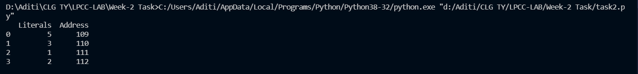

**LT.csv:**

,Literals,Address

0,5,109

1,3,110

2,1,111

3,2,112